Hygiene and cleaning in school  Everyone in school will sanitize their hands thoroughly before entering the building and at regular times during the day.  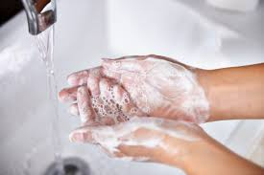  Pupils will be supported to wash their hands and hand gel will be available.  Enhanced cleaning arrangements are happening throughout the school day. All areas will have cleaning resources and teachers will also wipe down teaching spaces throughout the day.  Arrivals and Departures  There will staggered arrival and departure procedures.  Buses  - Buses to all arrive at 9.00am at the main entrance.  - Buses will wait until instructed before pupils to get off. This will help reduce cross over of pupils in corridors.  - Buses will pick up pupils at 3.15pm at the main entrance  Parents  - Parents are to drop off at either the main entrance or high school entrance at 9.20 – 9.30.  - Parents will pick up at their designated entrance at 3.30pm.  Please see your letter for details  Initially there will be no before school clubs |  | It is the Department of Education’s plan for all our pupils to be back in school in September  and we can’t wait to see them.  However, we understand you may have some concerns and questions.  Hopefully this booklet has helped you understand how we will make things as safe as possible  but if you have any questions please email: admin@lancasterian.manchester.sch.uk.  Look forward to seeing your child soon! |  | 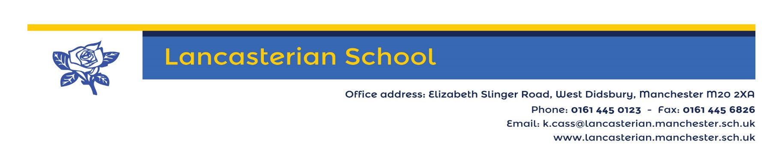  Safety procedures for September  The DfE guidance states:  Schools must comply with health and safety law, which requires them to assess risks and put in place proportionate control measures. Schools should thoroughly review their health and safety risk assessments and draw up plans for the autumn term that address the risks identified using the system of controls set out below. These are an adapted form of the system of protective measures that will be familiar from the summer term.  We have a risk assessment already in placed passed by Governors and Manchester LA. We have been proved with additional risk assessments by the LA and our risk assessment has been reviewed in line with these. Our risk assessment will continue to be reviewed as we receive new guidance and information.
It is accepted that our pupils cannot always follow strict social distancing rules or sit in formal learning organisation. We will aim to maximise space and contact by:

- Having only absolutely essential furniture in them to maximise space.
- Where appropriate pupils will have desks and only share these with 1 pupil side by side with a space between them.
- Where appropriate pupils will be helped to understand social distancing.

Reducing contact and contaminations- Staff
More staff rooms are available so staff can maintain social distancing and reduce contact with others.
Therapists will follow the NHS guidance and wear PPE to protect our pupils and staff.
Other cover staff will work across only a few classes.
Strict procedures for staff at all times regarding wipe down of teacher spaces or office spaces

What you need to do  We need to ensure everyone in school is safe so we need anyone (pupils and staff) showing any of the symptoms listed below to stay at home.  - high temperature  - new, continuous cough  - loss or change to sense of smell or taste  If a member of your household is showing symptoms your child needs to stay at home.  You need to contact school and book a test  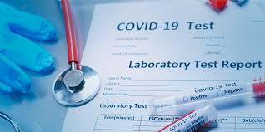  If a test is positive (regardless of symptoms) your child must stay at home for 7 days.  If a pupil starts to show symptoms in school they will be sent home and you will need to book a test.  NHS Test and Trace  As a school we are already engaging with the NHS Test and Trace system and will continue to do so in September. Records are being kept of all contacts and visitors.  Visitors  Only essential visitors including parents will be allowed in school. A risk assessment will have been completed identifying that a face to face visit is the only option. | Reducing contact and contaminations- Classes  Our class sizes are smaller than in mainstream school so already reduces the risk of transmission.  Classes will:  - Be their own bubble and have minimal contact with each other.  - Most lessons will take place in the pupils’ classes and movement around school will be strictly supervised. There will be no whole school assemblies.  - Have staggered break times and only share outside space with their partner class.  - Either eat lunch in their own class or in the dining hall with their partner class.  Pupils have their own pencil case/ wallet for their own regularly used resources. There will be strict procedures on use of other equipment – all activities will be risk assessed and planned.

