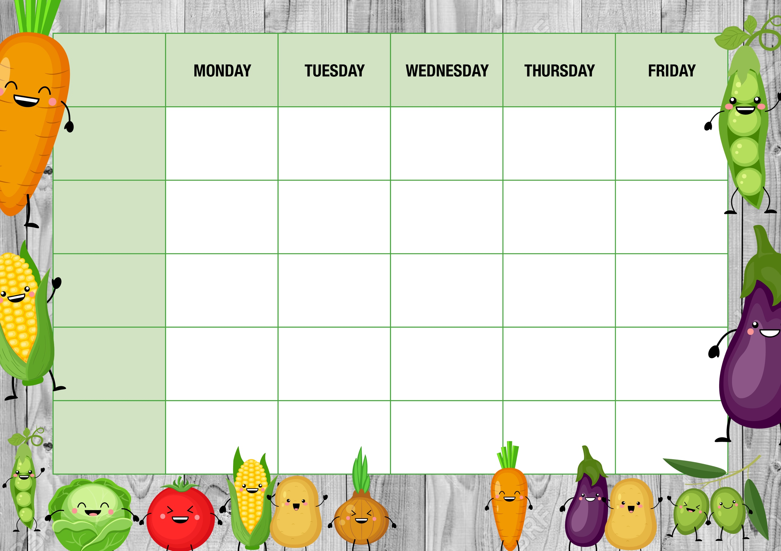

**Cheese Pasty**

*With Chips & beans*

**Chicken Fajita ‘Lasagne’**

*With Potato Wedges, and Corn*

**Iced Mousse Pot**

**Sweet waffle with custard**

**Cheesy Pasta**

*With Garlic Bread*

**Breaded Chicken Burger**

*With Chips, peas or beans*

**Oven baked Sausages**

*Mashed Potato or Chips, Carrots, gravy*

**Filled Jackets**

**\***

**Assorted Sandwiches**

**\***

**Tomato Pasta**

**Filled Jackets**

**\***

**Assorted Sandwiches**

**\***

**Tomato Pasta**

**Filled Jackets**

**\***

**Assorted Sandwiches**

**\***

**Tomato Pasta**

**Filled Jackets**

**\***

**Assorted Sandwiches**

**\***

**Tomato Pasta**

**Filled Jackets**

**\***

**Assorted Sandwiches**

**\***

**Tomato Pasta**

**Alternatives**

**Quorn Dippers**

*Baked Potato wedges, and corn*

**Cheese Whirl**

*With Baked Potato cubes, broccoli,*

**Sweet Treat**

**of the day**

**Ice Cream Roll**

**Meat free Balls**

*Mashed potato or Chips, Carrots, Gravy*

**Shortbread Biscuit**

**Cheese Whirl**

*With Baked Potato cubes, broccoli,*

**Fish & Chip Fry-yay!**

**Fish fingers**

*With Chips & beans*

**Freshly made salad Bar**

**\***

**Fresh Fruit & Yoghurt**

**\***

**Cheese & Crackers**

**Freshly made salad Bar**

**\***

**Fresh Fruit & Yoghurt**

**\***

**Cheese & Crackers**

**Freshly made salad Bar**

**\***

**Fresh Fruit & Yoghurt**

**\***

**Cheese & Crackers**

**Freshly made salad Bar**

**\***

**Fresh Fruit & Yoghurt**

**\***

**Cheese & Crackers**

**Freshly made salad Bar**

**\***

**Fresh Fruit & Yoghurt**

**\***

**Cheese & Crackers**

**Main offer**

**WEEK TWO**

**Meat Free**

**Dessert**

**Every day**