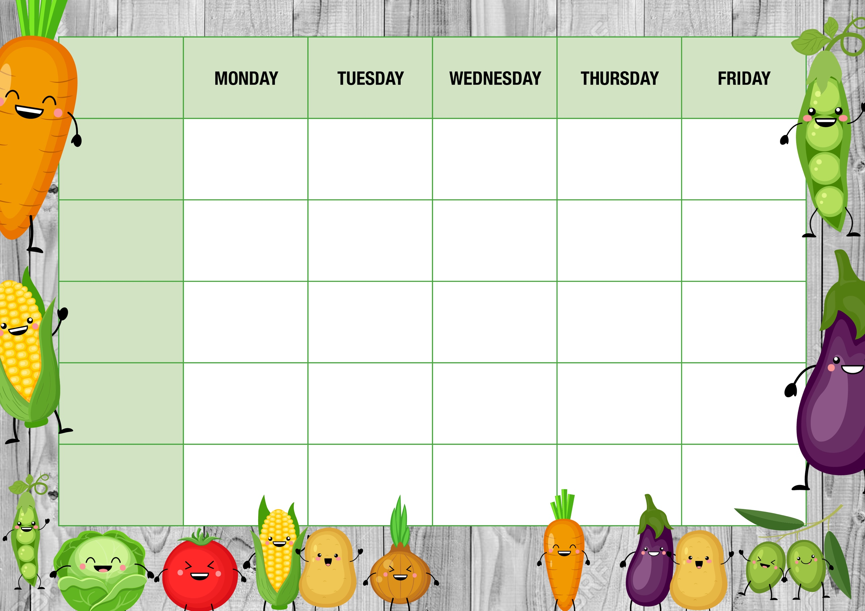

**Cheese Whirl**

*With Chips & beans*

**Quorn Lasagne**

*With Garlic bread*

**Home baked cookie**

**Fruity Jelly**

**Cheese Pasty**

*Baked Potato cubes, Peas or beans*

**Chicken Curry**

*Steamed Rice, Pitta bread*

**BBQ Chicken Burger**

*Chips, beans or Coleslaw*

**Filled Jackets**

**\***

**Assorted Sandwiches**

**\***

**Tomato Pasta**

**Filled Jackets**

**\***

**Assorted Sandwiches**

**\***

**Tomato Pasta**

**Filled Jackets**

**\***

**Assorted Sandwiches**

**\***

**Cheesy Pasta**

**Filled Jackets**

**\***

**Assorted Sandwiches**

**\***

**Tomato Pasta**

**Filled Jackets**

**\***

**Assorted Sandwiches**

**\***

**Tomato Pasta**

**Alternatives**

**Quorn Dippers**

*Baked Potato wedges, beans, or coleslaw*

**French bread style Pizza Baguette**

*With Baked Potato cubes, corn, salad*

**Sweet Treat**

**of the day**

**Baked Doughnut with Custard**

**Southern Fried Quorn Burger**

*Chips, beans or Coleslaw*

**Shortbread biscuit**

**French bread style Pizza Baguette**

*With Baked Potato cubes, corn, salad*

**Fish & Chip Fry-yay!**

**Fish fingers**

*With Chips & beans*

**Freshly made salad Bar**

**\***

**Fresh Fruit & Yoghurts**

**\***

**Cheese & Crackers**

**Freshly made salad Bar**

**\***

**Fresh Fruit & Yoghurts**

**\***

**Cheese & Crackers**

**Freshly made salad Bar**

**\***

**Fresh Fruit & Yoghurts**

**\***

**Cheese & Crackers**

**Freshly made salad Bar**

**\***

**Fresh Fruit & Yoghurts**

**\***

**Cheese & Crackers**

**Freshly made salad Bar**

**\***

**Fresh Fruit & Yoghurts**

**\***

**Cheese & Crackers**

**Main offer**

**WEEK ONE**

**Meat Free**

**Dessert**

**Every day**