Newsletter

Lavender:Morad Daffodils: Nerese Blossom:Peshawa Bluebells: Carlito Rose:Thabani Sunflowers: Azlan Jasmine:Mahmood Acorns:Isabelle
Elm:Ilyas Pine;Jayden Sycamore: Ngamdy Willows: Rowan: Maple: Caitria Cedar: Benji Birch:Farah Beech: Oak: Melanie

22nd September 2023
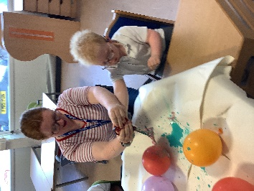
Dear Parents and Carers

FA football coaching
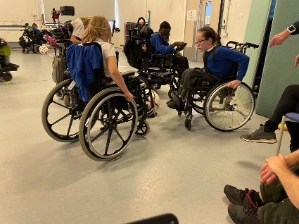
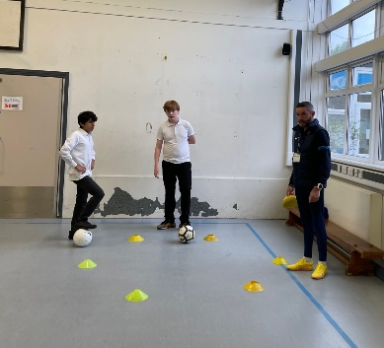
We have a weekly visit from a FA football coach to work on and develop our football skills. Oak class this week have had a great time and everyone was included!
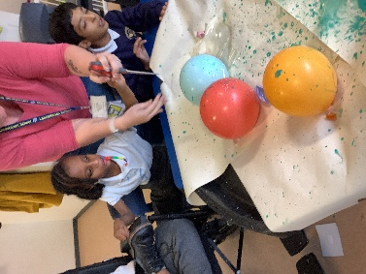
Enrichment session
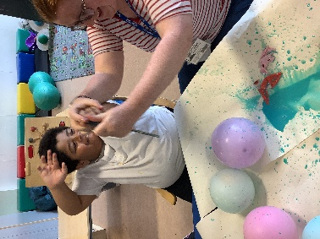
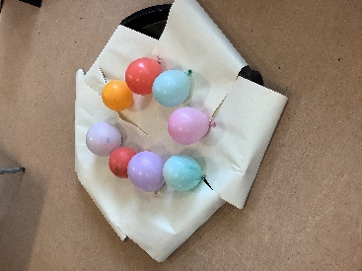
We still have our weekly enrichment sessions. Across the year classes will have the opportunity to develop their ‘Skills for Life’: teamwork, self-belief, problem solving, self-management and communication. This will look different in

different classes/curriculums.
Last week Bluebells class were working on their attention (self-
management/communication) and cause and effect (problem solving) skill. They also had lots of fun with balloons and paint!

Computing
All of our pupils develop their skills in using technology from our pre-formal curriculum to our formal curriculum. We are working with the ACE centre to develop Assistive Technology across the school.
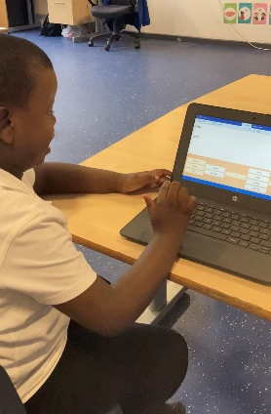
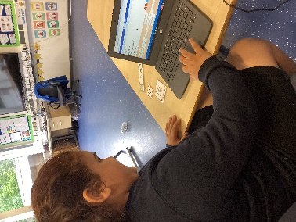
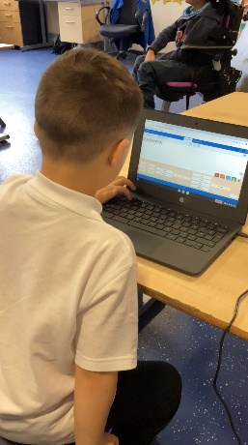
Within our formal curriculum children have specific computing lessons focusing on computing systems, , data and information creating media and programming. This week Jasmine class were learning about computing systems and how it can support them.

Dates for the term
Harvest festival donations by 16th October

Best Wishes
Alison Randall
Headteacher

